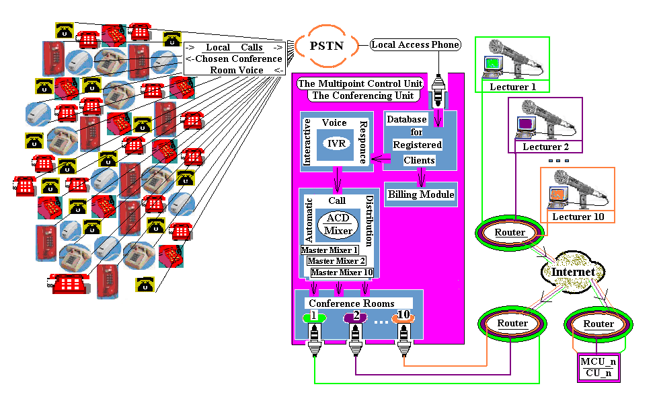 Required Conference Calls Flow:
--Caller dial a local number -- Media gateway/media server (MG/MS) accepts the call and automatically mutes it so all the callers become passive listeners if number is registered in the Data Base; if the number is not registered the call is discarded --MG/MS plays Welcome message --MG/MS asks for a virtual conference room number --Caller enters virtual conference room number --Caller is entered into virtual conference room associated with the virtual conference room number. All callers entered virtual conference room number are now in associated virtual conference room --MG/MS accepts any caller’s decision to switch to a different virtual conference room by entering appropriate virtual conference room number without making another call (without leaving the system) --MG/MS permits the caller to terminate the call at will --MG/MS of our “dream” has to be able to process up to 50, 000 callers simultaneously --MG/MS provides billing.

